

|  |
| --- |
|  |
| Software Review  Rapid Application Development |
| |  |  |  | | --- | --- | --- | | TheMisSprints | 6/9/20 | Rapid Application Development | |

TABLE OF CONTENTS

Requirements Overview 2

Current Requirements (05/06/2020) 2

Test Case 10

Test on current user input forms and web multi platform display (05/06/2020) 10

Updated Client Requirements 11

Client meeting overview (05-06-2020) 11

Updated Client Requirements 11

User interface Design mock up 12

User Subscribe Page 12

Admin Login Page 12

Admin Page – Main Dashboard 13

Movie Database Table 13

Subscriber List & Remove from Subscription page 14

Add Movie to Database Page 14

Business Requirements 15

Updated as of 06/06/2020 15

Requirements Traceability Matrix 15

Updated as of 06/06/2020 15

Test Cases 16

Updated as of 06/06/2020 16

# Requirements Overview

## Current Requirements (05/06/2020)

|  |  |  |  |
| --- | --- | --- | --- |
|  | Requirement | Completed | Comments/Reference |
| 1 | Index page contains navigation bar. | YES | See ref 1 |
| 2 | Index page includes logo. | YES | See ref 2 |
| 3 | Movies will be categorized by genre, collections or popular. | YES | See ref 3 |
| 4 | Popular movie titles will be numbered by most searched, in the Popular section page. | YES | See ref 4 |
| 5 | Search page will contain search fields for the movie title, genre, rating and year. | YES | See ref 5  Comments: Search form displays low on the screen and not in the middle. |
| 6 | Search page will display search results. | YES | See ref 6 |
| 7 | Search page will allow user to select on result movie titles which will direct them to that selected movie’s information page. | YES | See ref 7 |
| 8 | Search form must allow user to search by any combination of search inputs, whether it is all search field inputs or part’s of.  For example;  Title, genre, rating and year  Title, genre and year  Genre and year  Genre | YES | See ref 8 |
| 9 | If there is no movies within the search input details, a no results page must be shown to the user | YES | See ref 9 |
| 10 | Movie information page will include the movie poster, trailer, rating and details. | YES | See ref 10 |
| 11 | Website must be able to adapt to multiple device screen sizes. | YES |  |

Image Reference 1

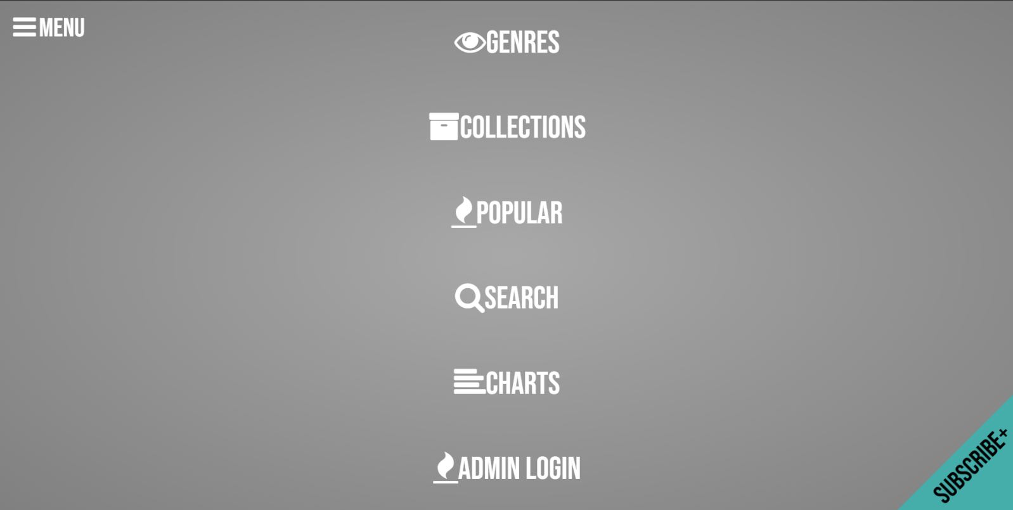

Image Reference 2

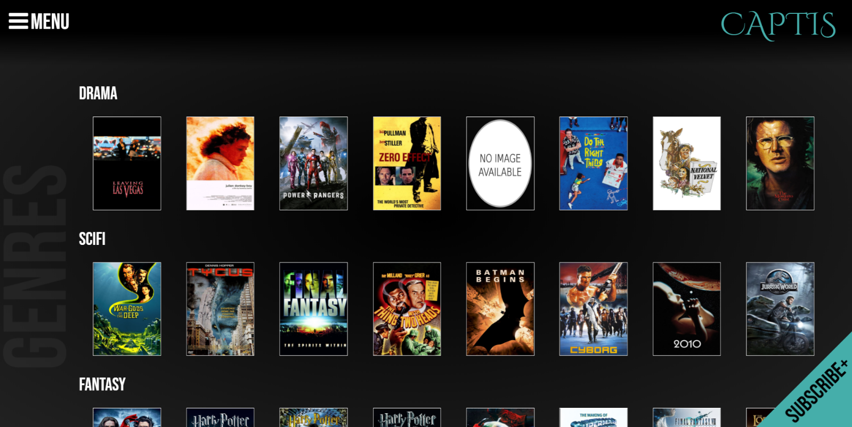

Image Reference 3

Genres

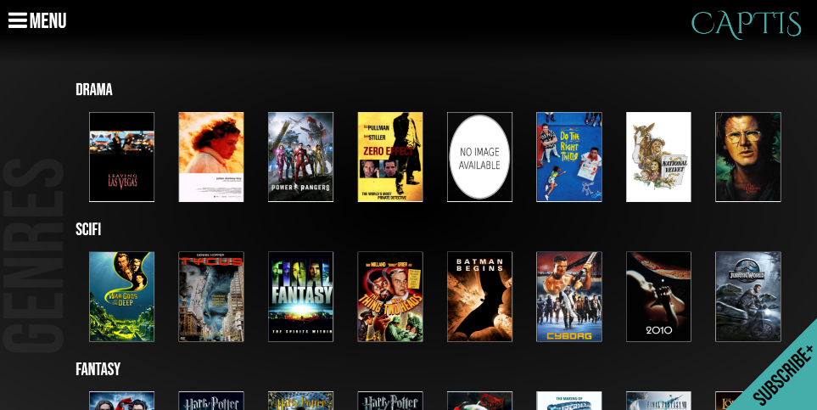

Collection

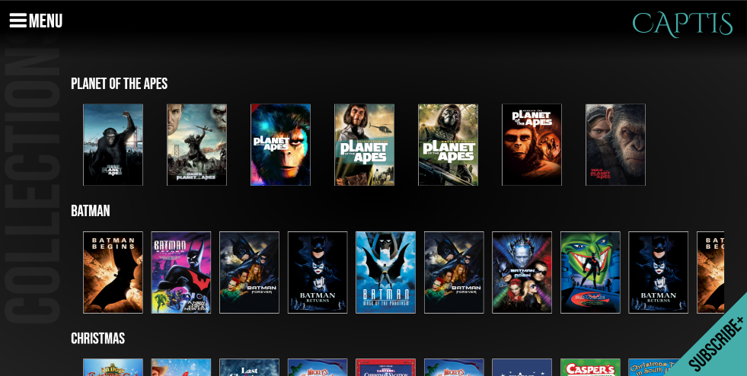

Popular

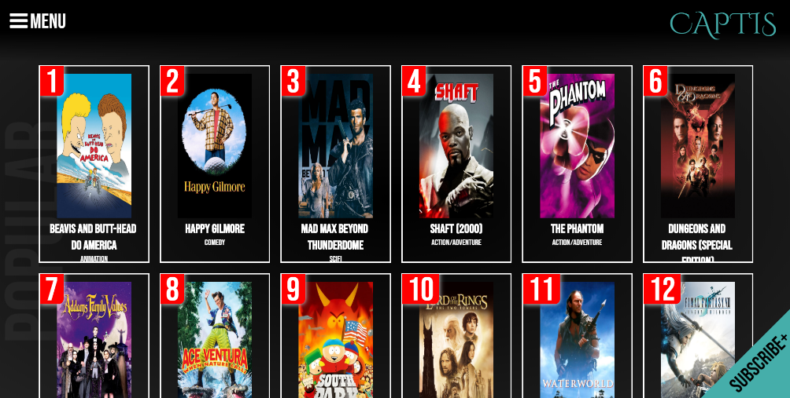

Image Reference 4

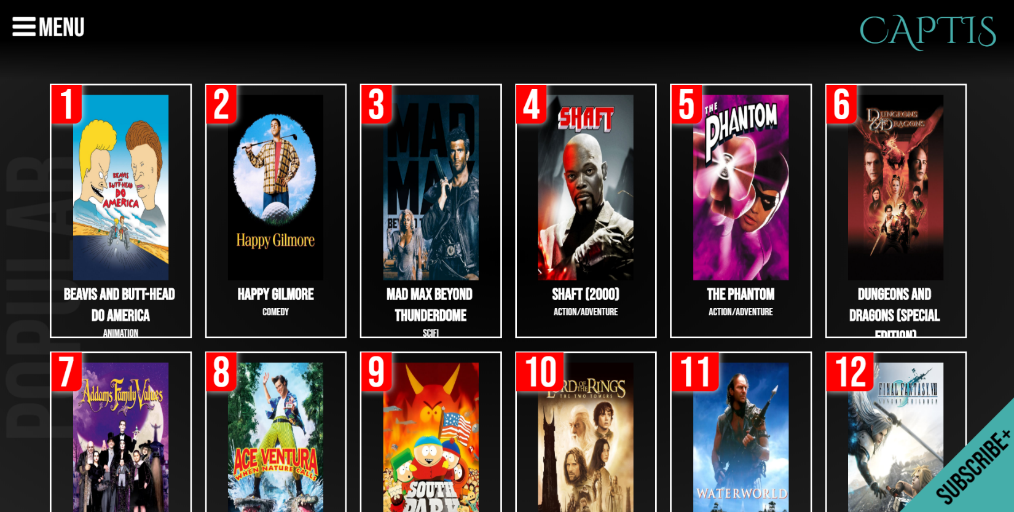

Image Reference 5

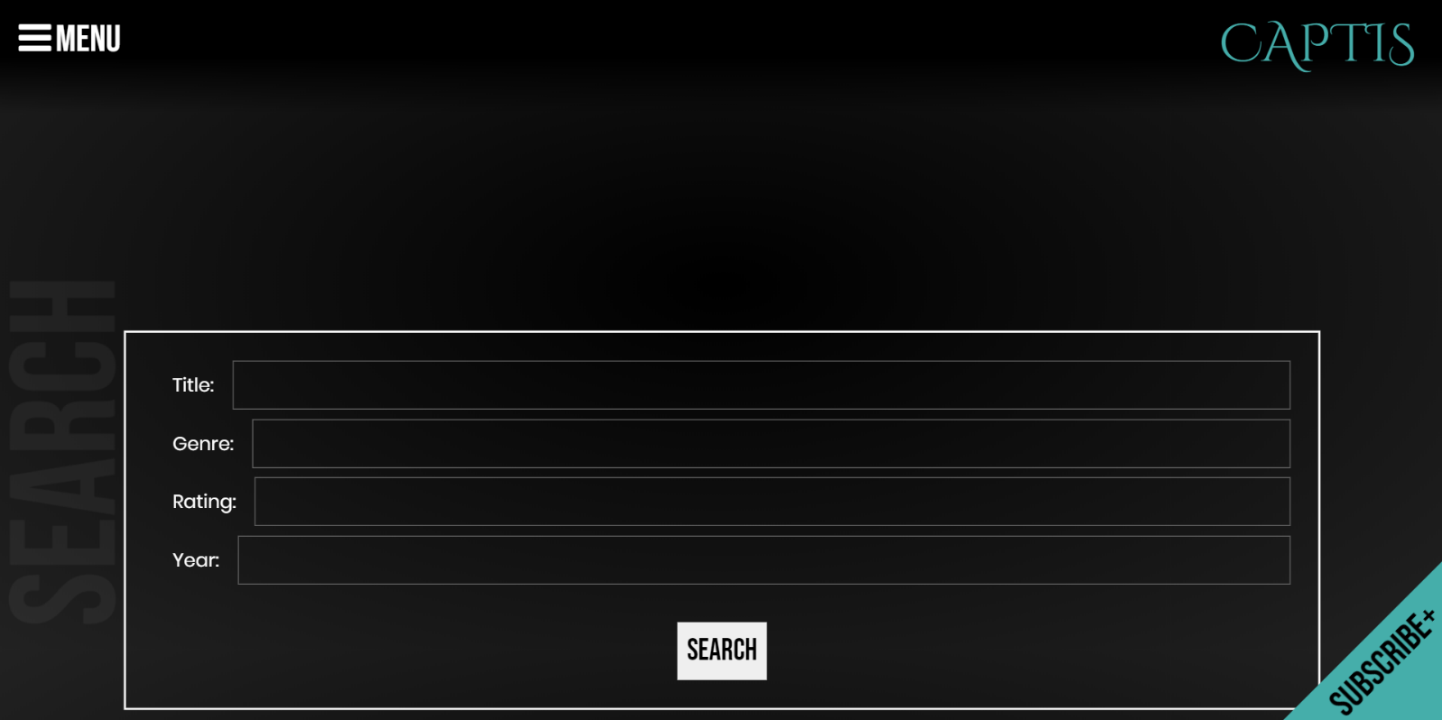

Image Reference 6

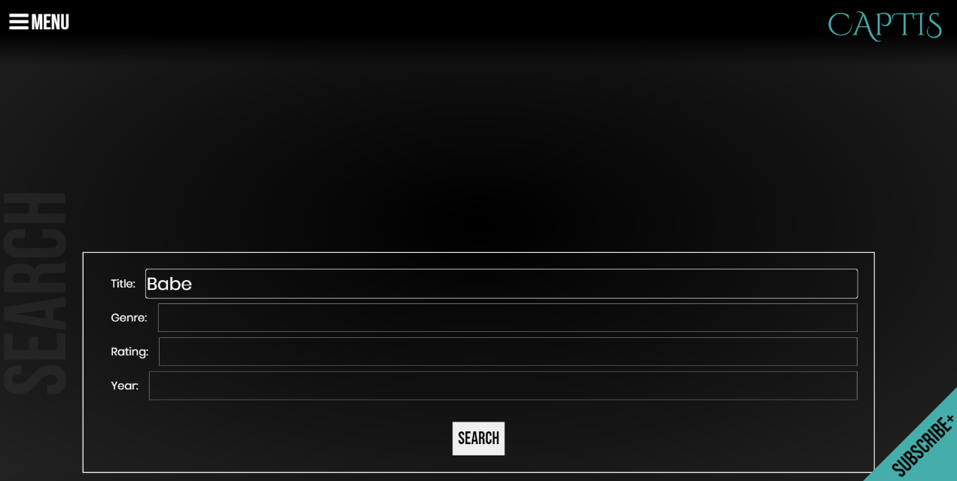

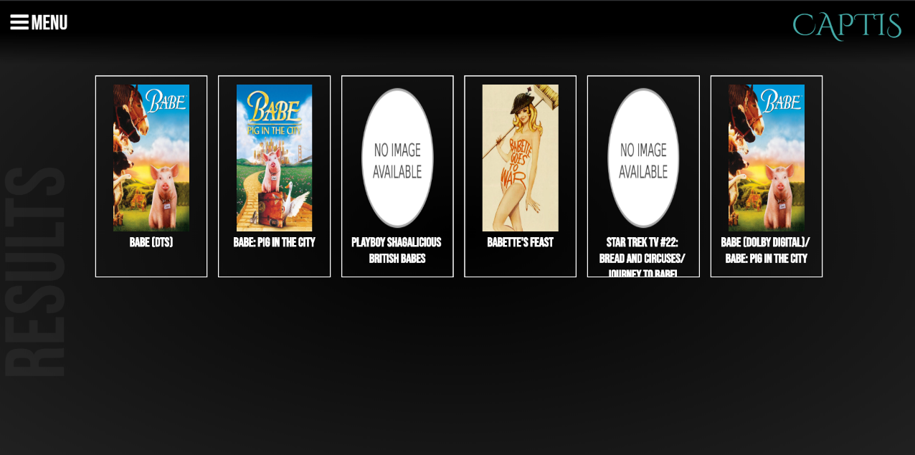

Image Reference 7

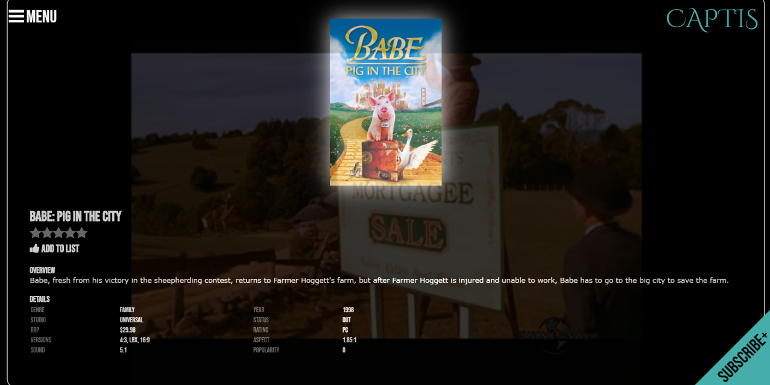

Image Reference 8

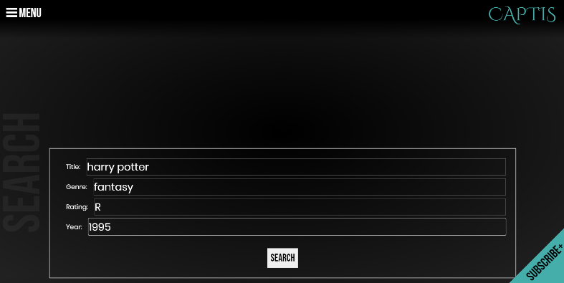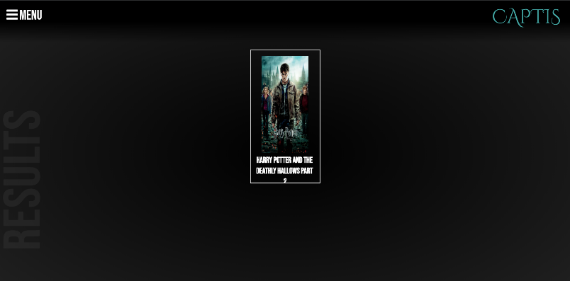

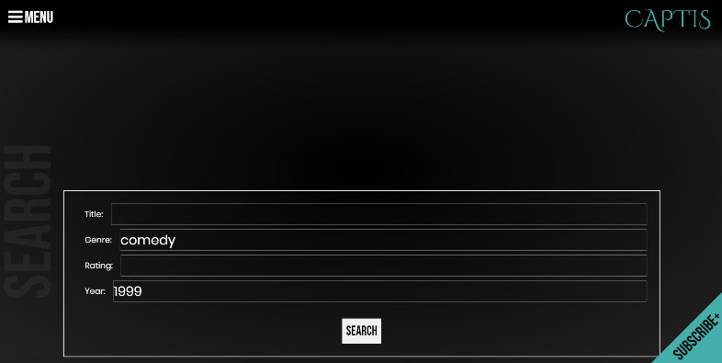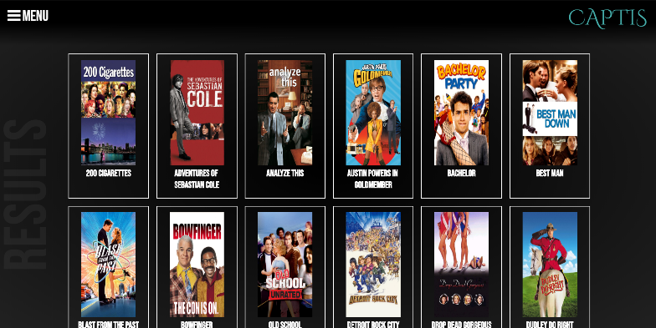

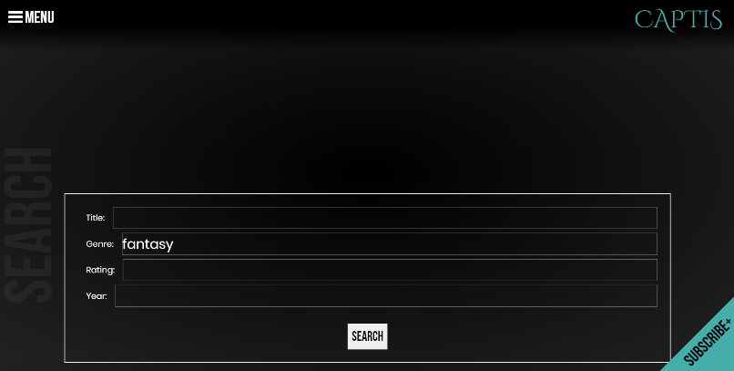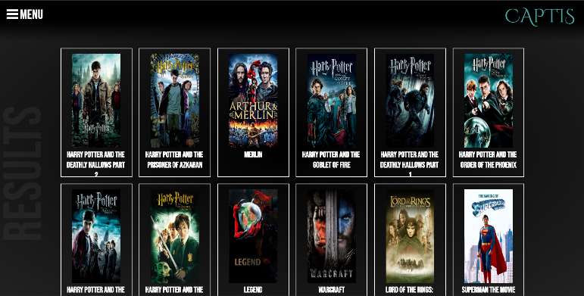

Image Reference 9

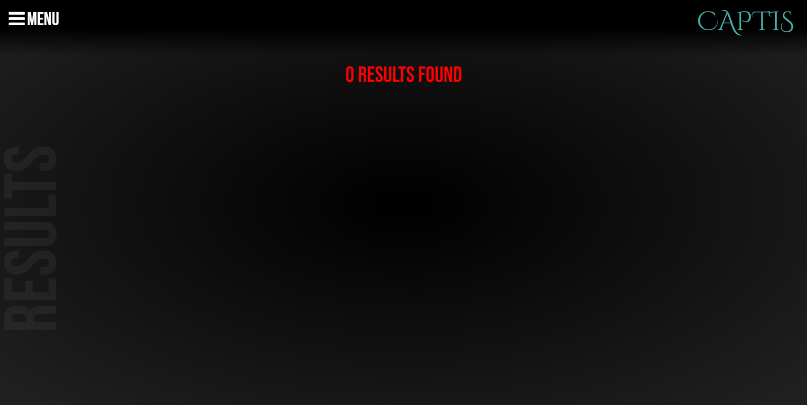

Image Reference 10

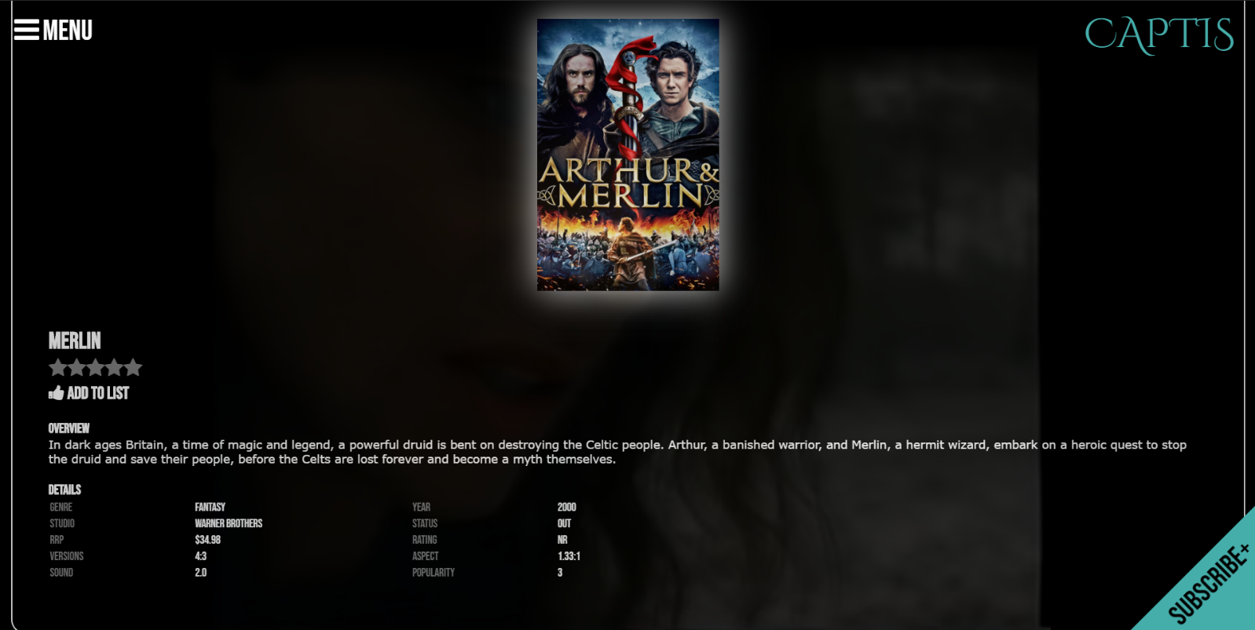

Image Reference 11

PC Screen

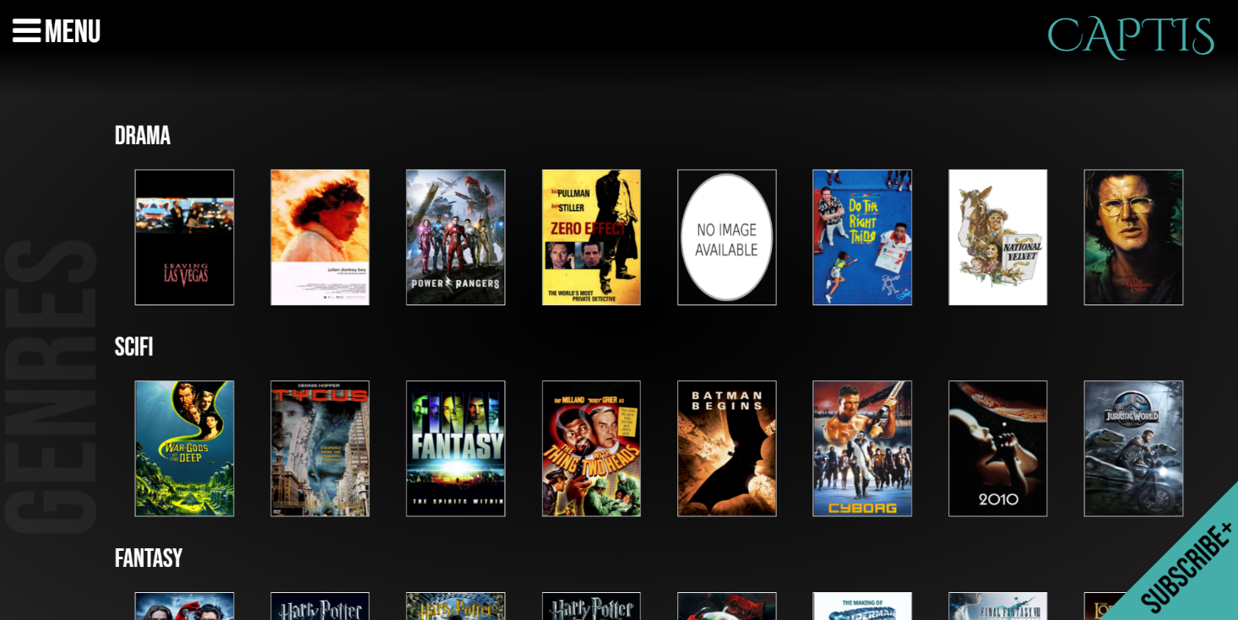

Iphone Ipad

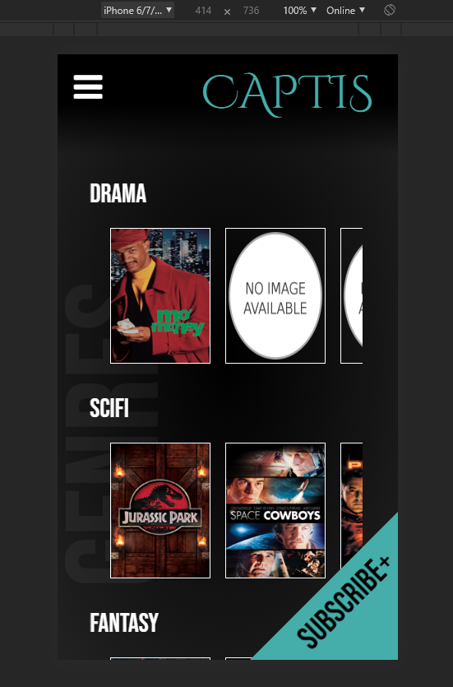 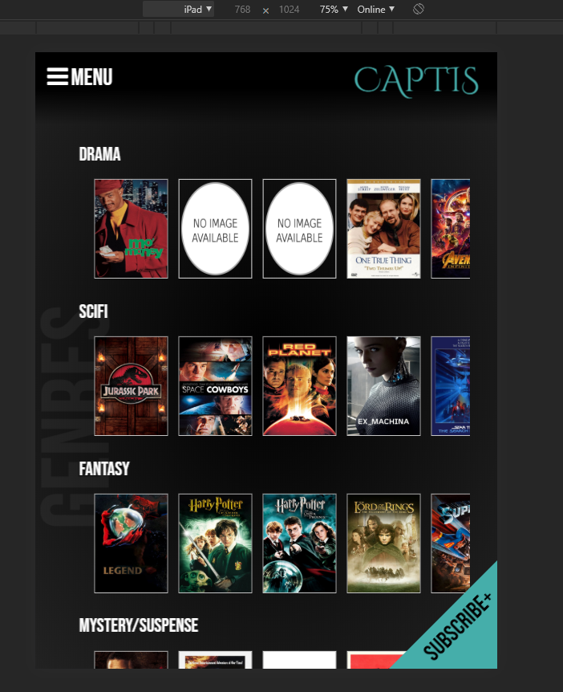

# Test Case

## Test on current user input forms and web multi platform display (05/06/2020)

|  |  |  |  |
| --- | --- | --- | --- |
|  | Test Case | Pass/Fail | Comments |
| 1 | Search form searches movies with all inputs filled | Pass |  |
| 2 | Search form searches movies with either fields filled | Pass |  |
| 3 | Search form displays “no results” to user if there is no movies that match search criteria | Pass |  |
| 4 | Web application displays correctly on PC screen | Pass |  |
| 5 | Web application displays correctly on android devices | Issues to be fixed | All pages display correctly on device, only issue is on the charts page, the genre titles are squished to the left.  See Image Ref 1 |
| 6 | Web application displays correctly on Iphone devices | Issues to be fixed | All pages display correctly on device, only issue is on the charts page, the genre titles are squished to the left.  See Image Ref 2 |
| 7 | Web application displays correctly on tablets/Ipads | Pass |  |

Image Reference 1 Image Reference 2

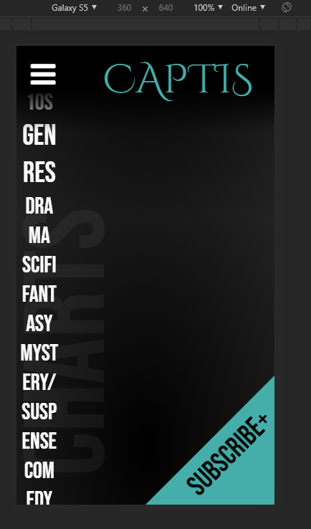 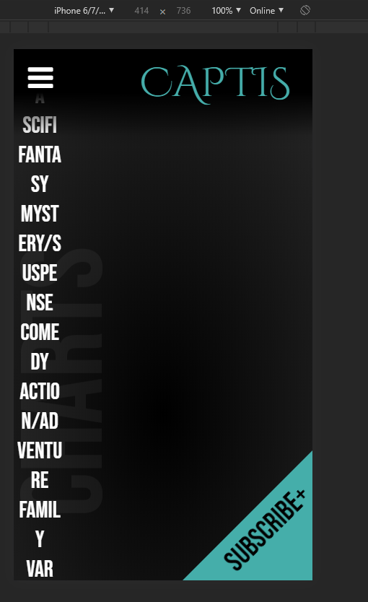

# Updated Client Requirements

## Client meeting overview (05-06-2020)

### Updated Client Requirements

1. A monthly newsletter and burst newsletter subscription
2. Admin page that allows admin to view all users subscribed and allows to remove when users opt to unsubscribe.

From the given two new client requirements for the movie database project, the following requirements will be added.

1. Users will be directed to a subscribe page when they click on the subscribe tab
2. Users will be asked for their full name, email and the option to select monthly, burst or both when they submit their subscription details.
3. Database must be able to accept all email varieties, e.g Hotmail, gmail, outlook, etc.
4. Users are able to unsubscribe to the newsletter, which just requires their email address.
5. When a user submits to unsubscribe, an email will be sent out to the admin email that informs that this user wants to unsubscribe.
6. On the movie database webpage, there will be a admin page that only allows the admin to see the current subscriptions and allows to delete members when admin receives the unsubscribe email.

# User interface Design mock up

## User Subscribe Page

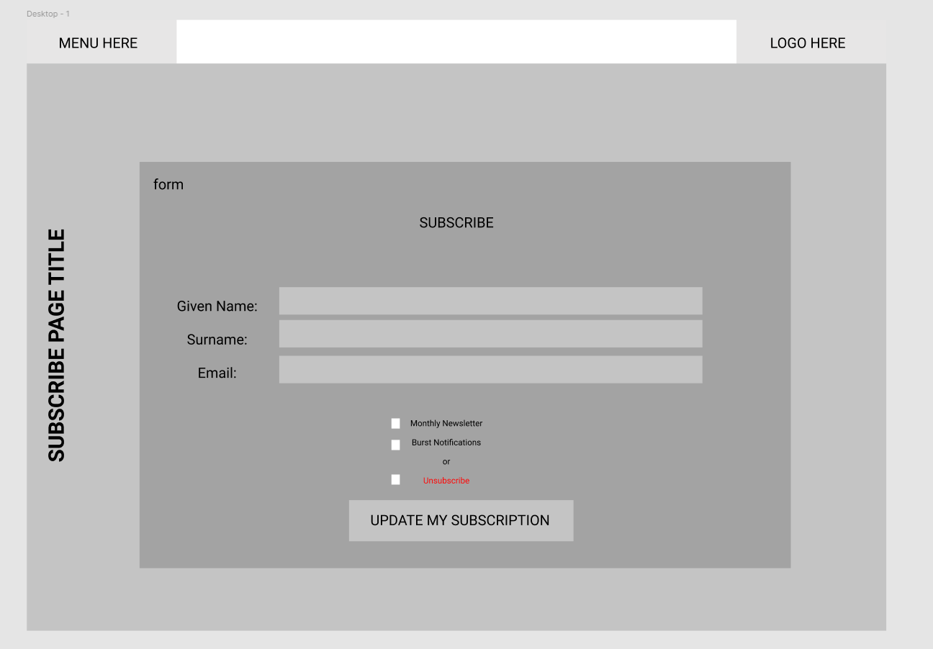

## Admin Login Page

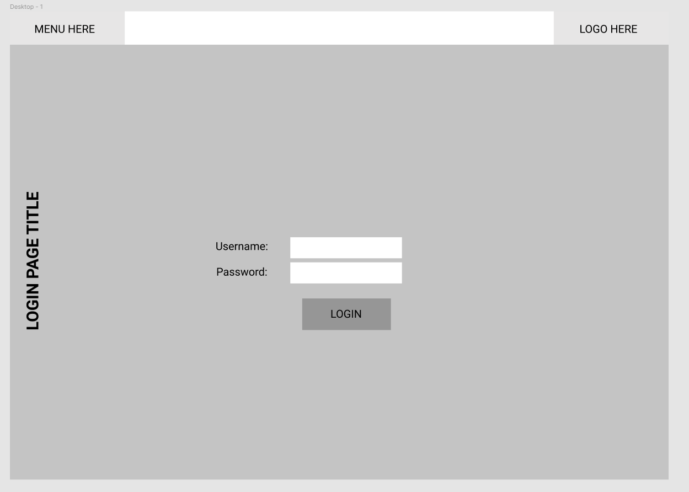

## Admin Page – Main Dashboard

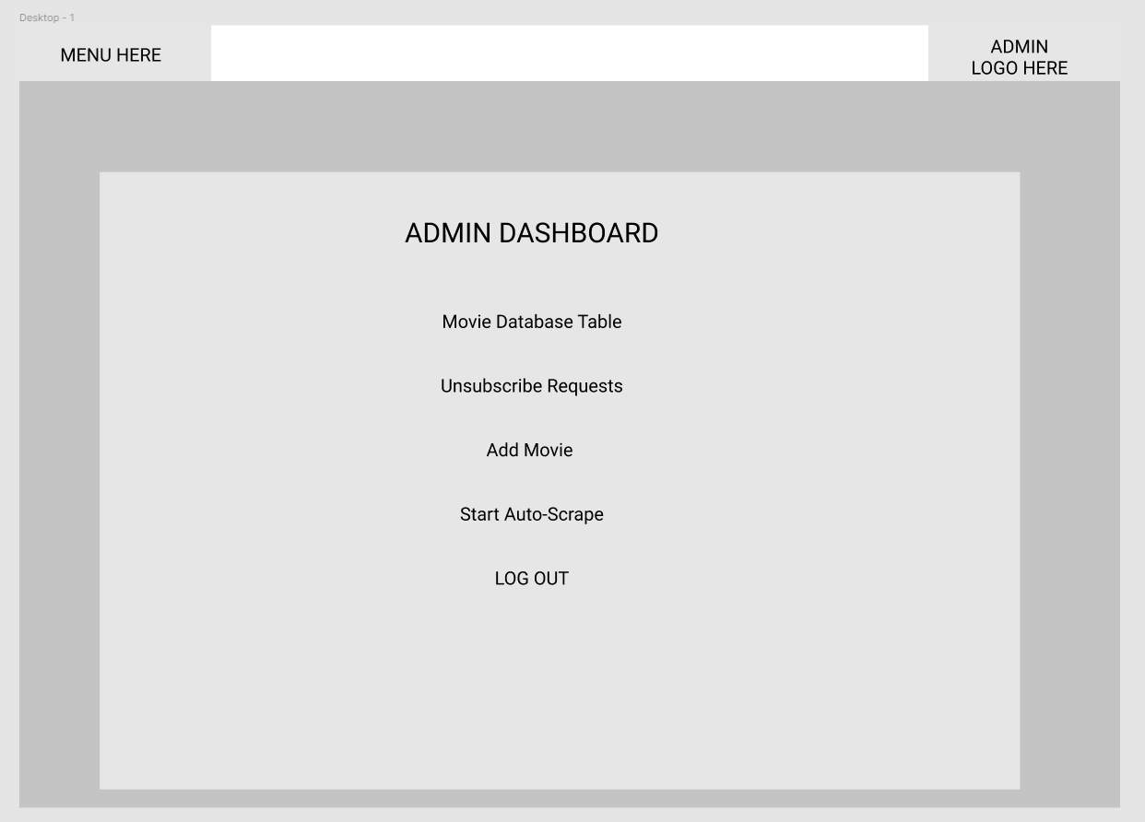

## Movie Database Table

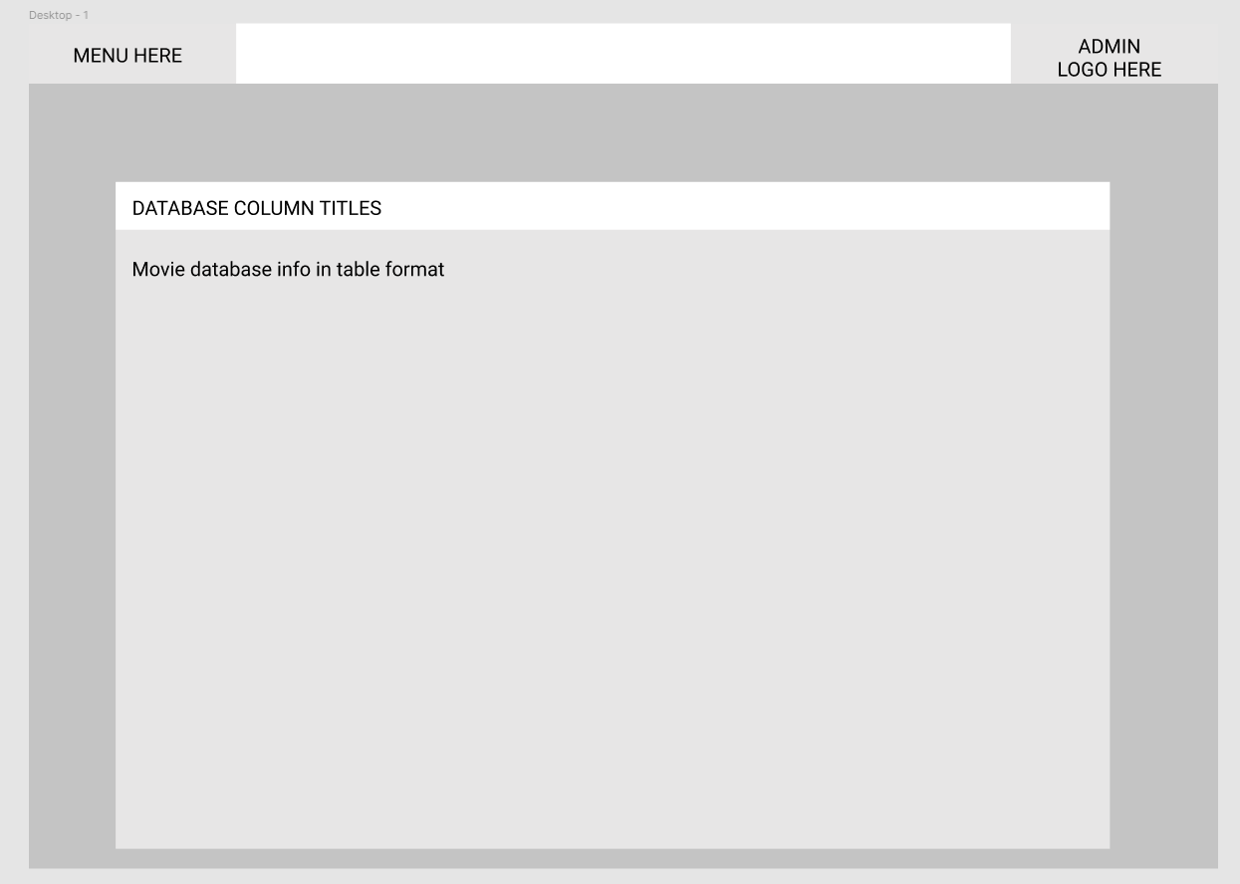

## Subscriber List & Remove from Subscription page

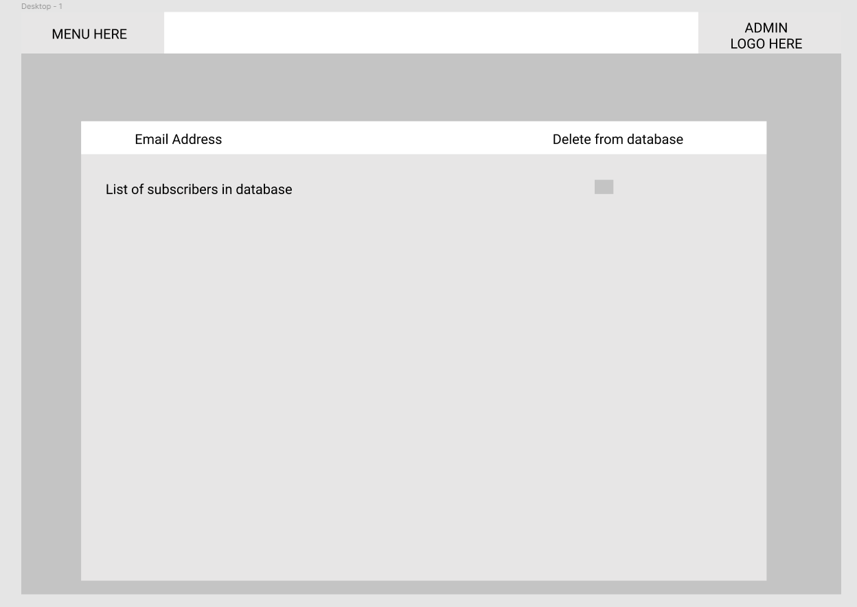

## Add Movie to Database Page

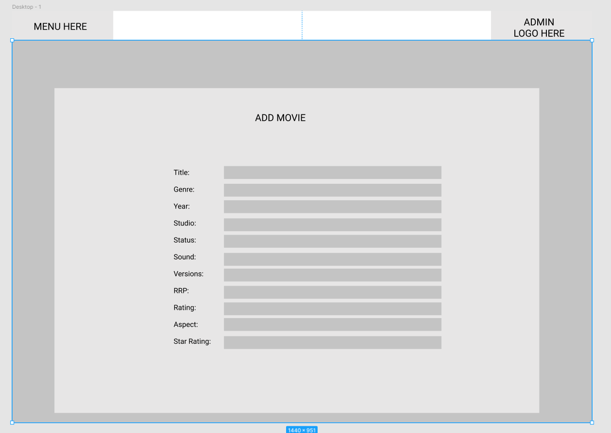

# Business Requirements

## Updated as of 06/06/2020

The below table defines the business requirements for the current sprint.

|  |  |
| --- | --- |
| Code | Requirement Description |
| BR1 | The website must contain a member’s signup page which adds members to the database. |
| BR2 | Selection of monthly notifications. |
| BR3 | Selection of burst notifications. |
| BR4 | Have a remove subscription option. |
| BR5 | This function should email the administrator requesting the removal of the user’s database entry. |
| BR6 | Member’s full name and email address should be validated before entry. |

# Requirements Traceability Matrix

## Updated as of 06/06/2020

Below is the requirements traceability matrix outlining the cases responsible for the testing of the individual business requirements.

|  |  |  |  |
| --- | --- | --- | --- |
| Business Requirement | Test Case # | Defects | Status |
| BR1 | 1 | - | Satisfied |
| BR2 | 3, 4, 5, 8 | - | Satisfied |
| BR3 | 3, 4, 6, 8 | - | Satisfied |
| BR4 | 9, 10 | - | Satisfied |
| BR5 | 9, 10 | - | Satisfied |
| BR6 | 2, 3, 4, 5, 6, 7, 8 | - | Satisfied |

# Test Cases

## Updated as of 06/06/2020

|  |  |  |  |  |
| --- | --- | --- | --- | --- |
| # | Functionality | Data used / Input | Expected Result | Pass / Fail |
| 1 | Subscribe | Clicked ‘Subscribe+’ button | Navigates to subscription form. | PASS |
| 2 | Subscribe | Subscribe with:   * Invalid first name * Valid last name * Valid email address * Monthly box ticked * Burst box ticked | Error showing invalid name. Subscription does not continue. | PASS |
| 3 | Subscribe | Subscribe with:   * Valid first name * Invalid last name * Valid email address * Monthly box ticked * Burst box ticked | Error showing invalid name. Subscription does not continue. | PASS |
| 4 | Subscribe | Subscribe with:   * Valid first name * Valid last name * Invalid email address * Monthly box ticked * Burst box ticked | Error showing invalid email address. Subscription does not continue. | PASS |
| 5 | Subscribe | Subscribe with:   * Valid first name * Valid last name * Valid email address * Monthly box ticked * Burst box un-ticked | Notification stating subscription has been successful. User is added to the database table ‘subscriptions’, showing 1 for monthly, 0 for burst. | PASS |
| 6 | Subscribe | Subscribe with:   * Valid first name * Valid last name * Valid email address * Monthly box un-ticked * Burst box ticked | Notification stating subscription has been successful. User is added to the database table ‘subscriptions’, showing 0 for monthly, 1 for burst. | PASS |
| 7 | Subscribe | Subscribe with:   * Valid first name * Valid last name * Valid email address * Monthly box un-ticked * Burst box un-ticked | Notification stating subscription has been successful. User is added to the database table ‘subscriptions’, showing 0 for monthly, 0 for burst. | PASS |
| 8 | Subscribe | Subscribe with:   * Valid first name * Valid last name * Valid email address * Monthly box ticked * Burst box ticked | Notification stating subscription has been successful. User is added to the database table ‘subscriptions’, showing 1 for monthly, 1 for burst. | PASS |
| 9 | Unsubscribe | Unsubscribe with:   * Email address not on subscription list | Notification saying request has been sent to administration. | PASS |
| 10 | Unsubscribe | Unsubscribe with:   * Email address on subscription list | Notification saying request has been sent to administration. | PASS |